Problem Statement: Launch jenkins and explore creating projects and users

1.**Installing Jenkins in EC2:**

Step 1:

Install Java:

$sudo apt update

$sudo apt install fontconfig openjdk-17-jre

$java -version

O/P img,

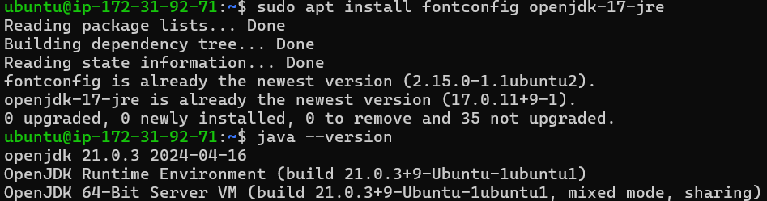

Step 2:

Install Jenkins:

$sudo wget -O /usr/share/keyrings/jenkins-keyring.asc \

https://pkg.jenkins.io/debian-stable/jenkins.io-2023.key

$echo "deb [signed-by=/usr/share/keyrings/jenkins-keyring.asc]" \

https://pkg.jenkins.io/debian-stable binary/ | sudo tee \

/etc/apt/sources.list.d/jenkins.list > /dev/null

$sudo apt-get update

$sudo apt-get install jenkins

Step 3:

Integrating Jenkins with docker:

$sudo usermod -aG docker ubuntu(Username)

$sudo usermod -aG docker jenkins

Step 4:

Launching jenkins:

On launching Jenkins for the 1st time, user will be trying to get the password for login, for that we need use the below command,

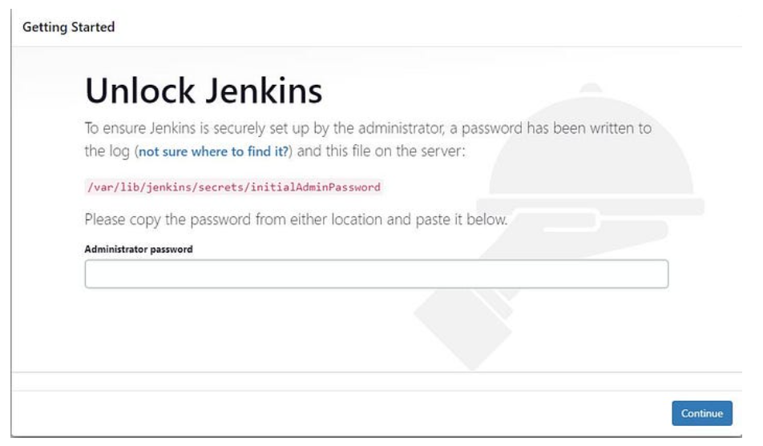

$sudo cat /var/lib/jenkins/secrets/initialAdminPassword

The terminal will provide the password and paste the password in the box given.

Then click on Install the suggested plugins

Step 5:

User account creation:

Create account by providing the,

username,

password,

confirm password,

full name,

E-mail Address,

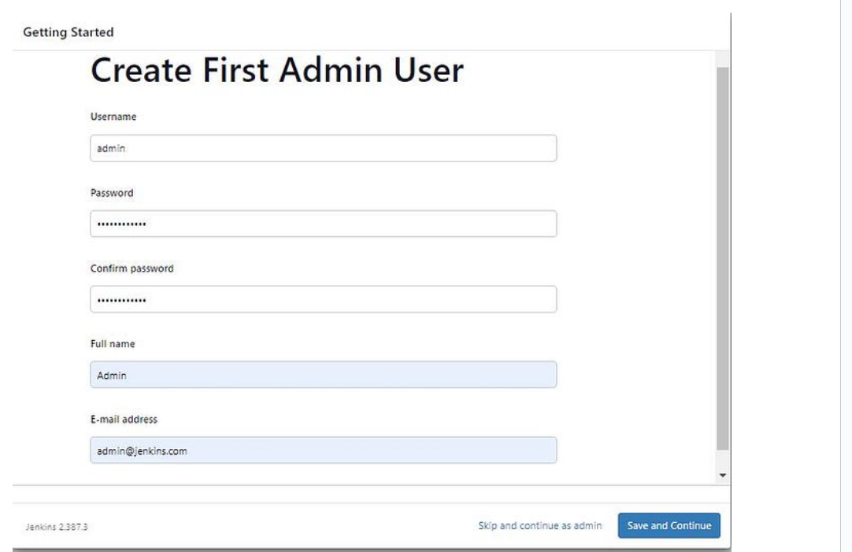

After creating the account user will be landed to the jenkins dashboard and user account creation is successfull.

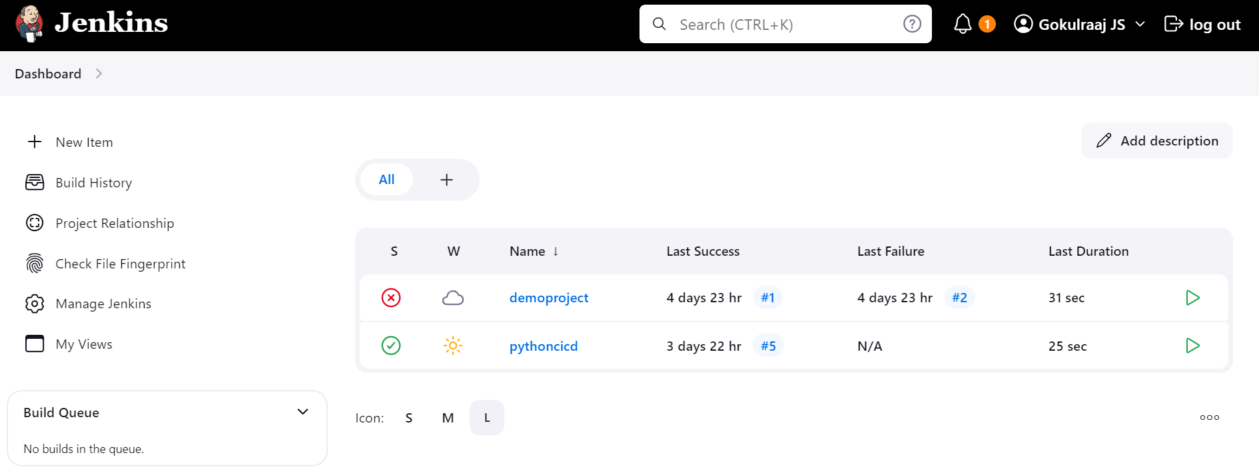

2. **Exploring project creation:**

Click on “New Item”

The following options will be listed of which select “freestyle project”

Name the project and click Ok

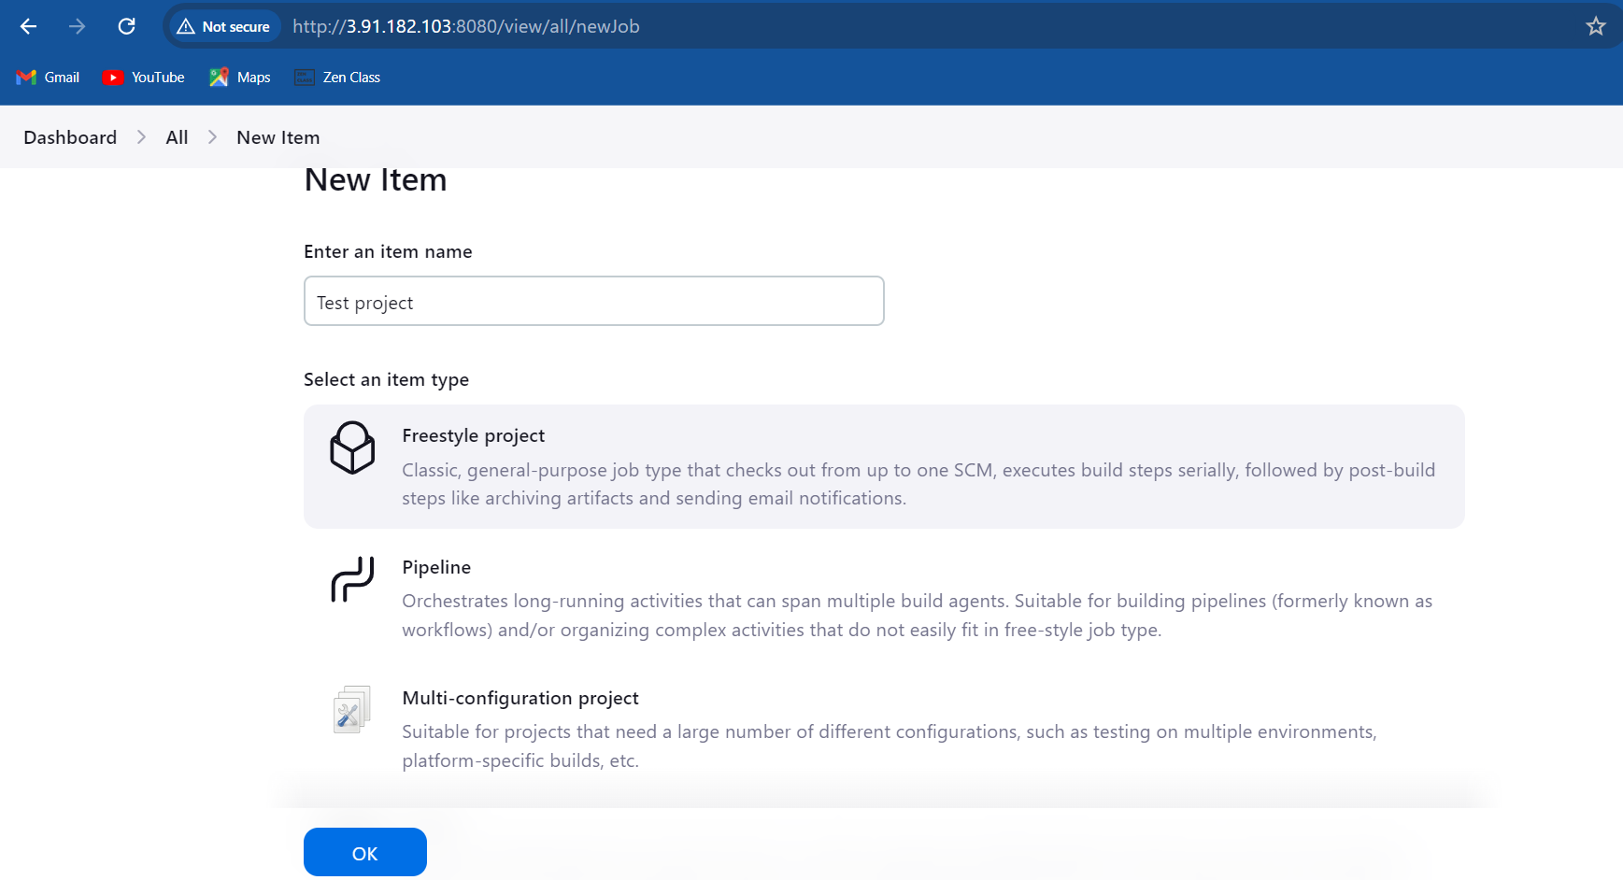

Under Source code management, select “Git” and add the link of the git and fill the details like branch name,

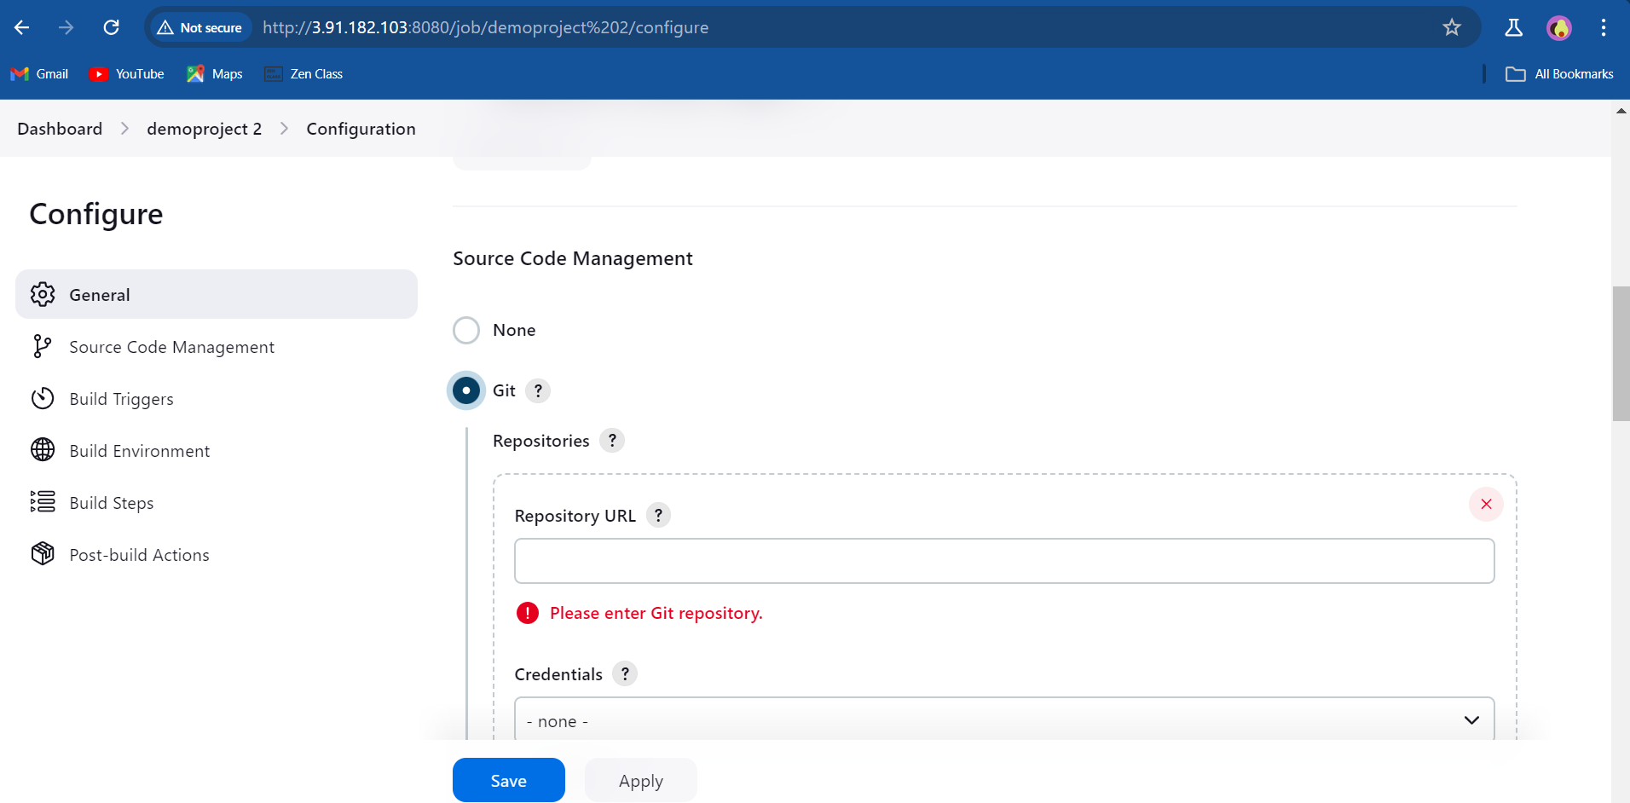

Under Build Steps, give the following commands,

$docker stop mynewcont

$docker rm mynewcont

$docker build -t myimg .

$docker run -d --name mynewcont-p 7000:8000 myimg

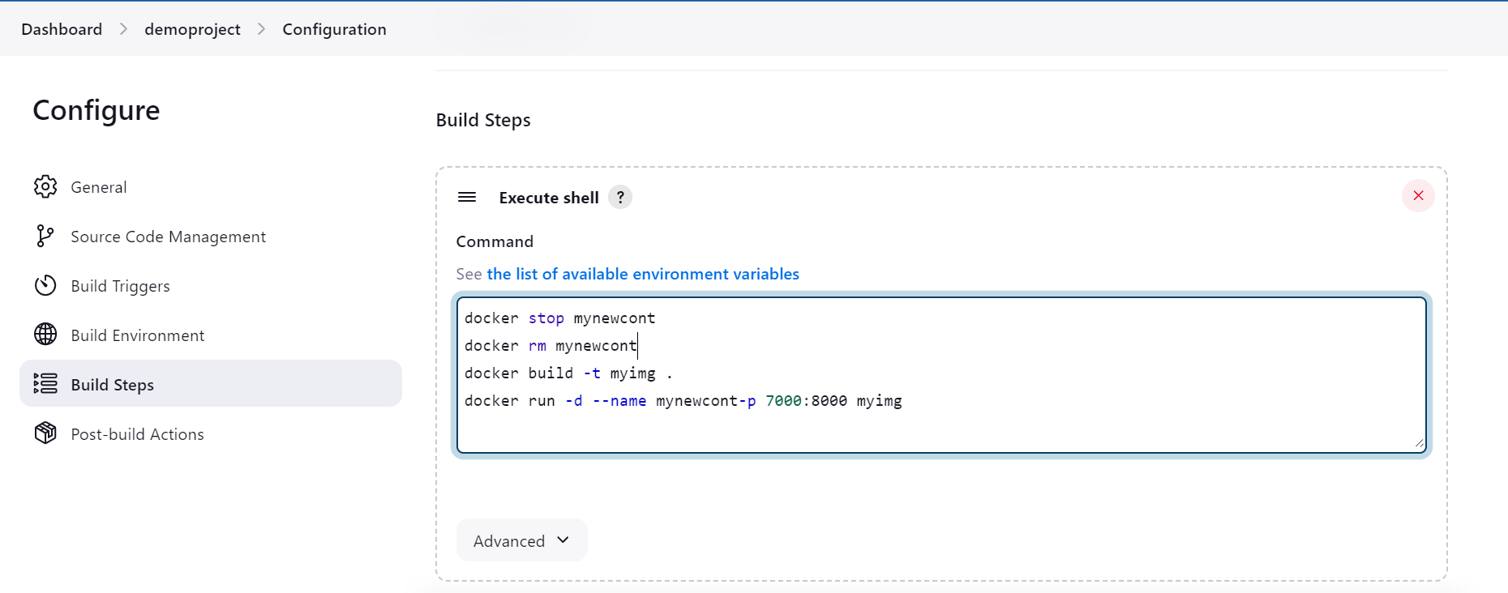

Click Apply and Save.

Now a new freestyle project is created.

3. **Exploring user creation:**

Go to Jenkins dashboard,

Click Manage Jenkins

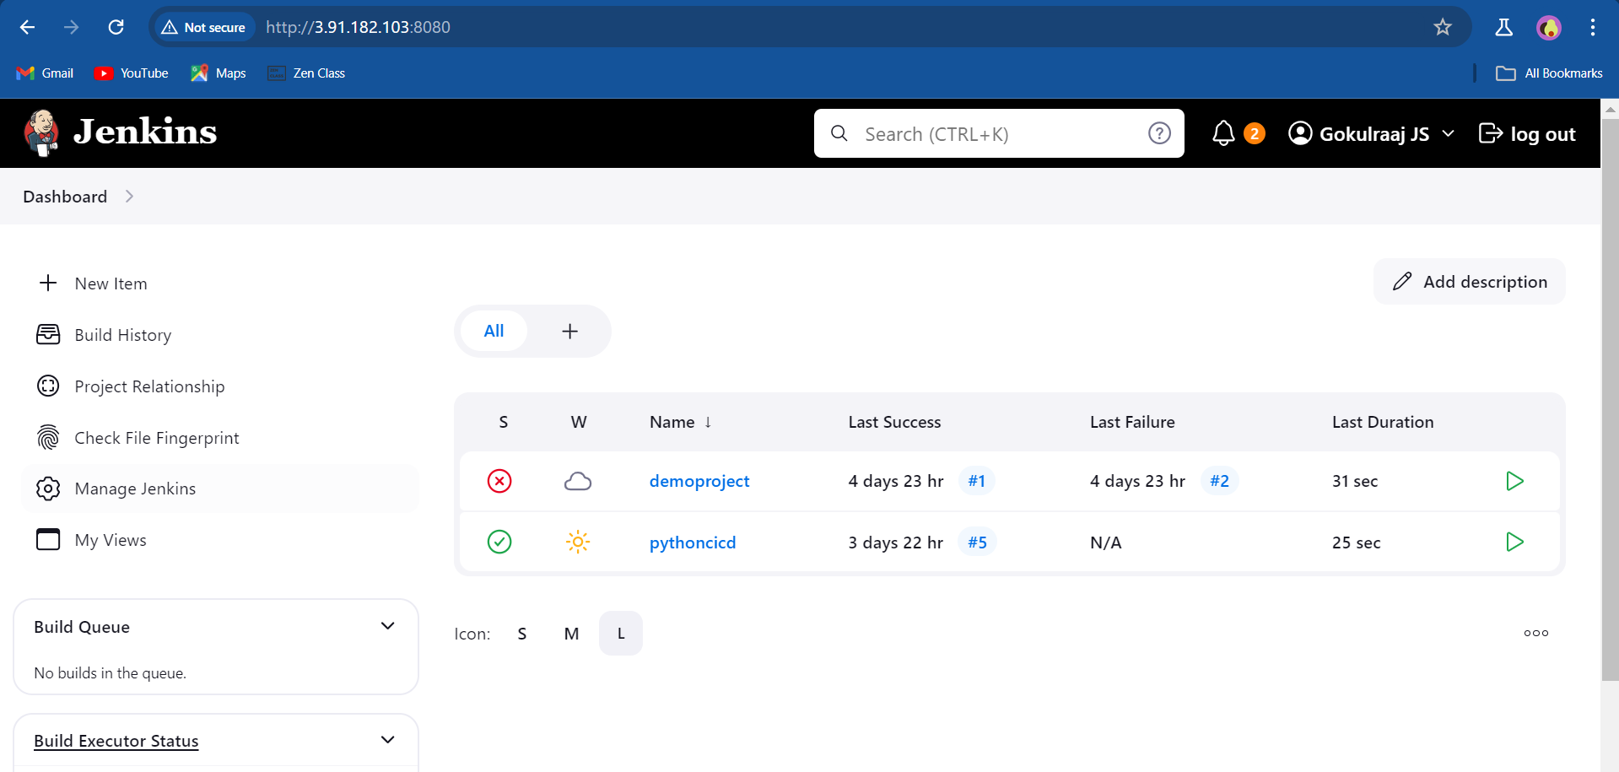

Under Manage Jenkins, click on the Users option, to list the available users to access the Jenkins,

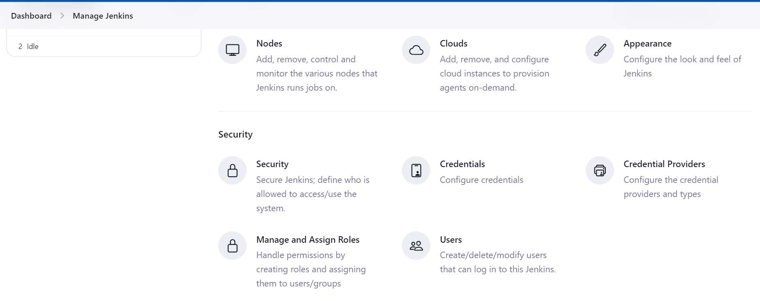

The user tab will list the available and we can also create users if we need,

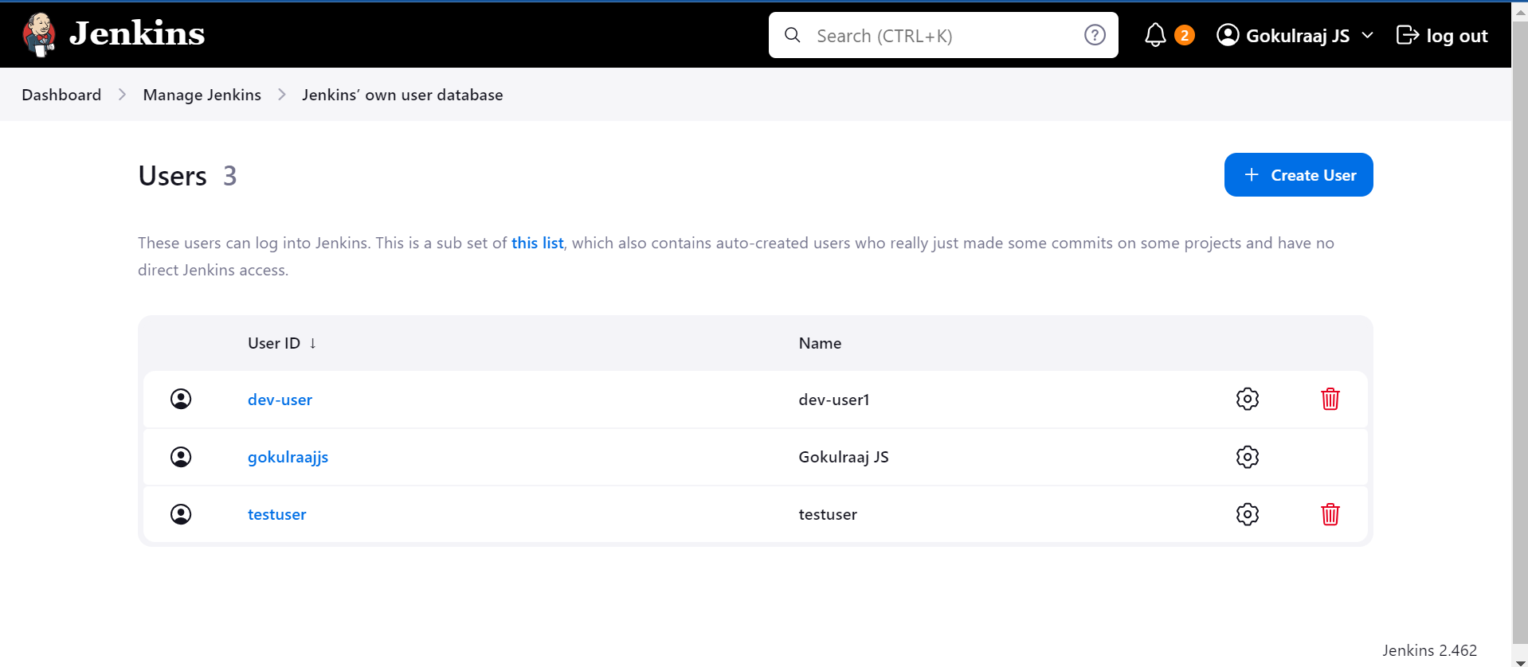

To create new user click “Create User” and fill the required fields,